Template for Properly Formatted

Electronic Journal of Severe Storms Meteorology Submissions

AUTHOR LIST #1
Affiliation #1, City, State or Country

AUTHOR LIST #2
Affiliation #2, City, State or Country

(Submitted 2 January 2022; in final form 22 May 2022)

ABSTRACT

The abstract is in 10-point font, Times New Roman, full-justified. The abstract should summarize the paper in 250 words or less, preferably in a single paragraph. Main-body text, appendices (if any) and references are the same 10-point font. Double spacing should separate sentences in the abstract and text body. Reference formatting details appear in a separate EJSSM document.

––––––––––––––––––––––––

1. Introduction

The bow echo (Fujita 1978) is a distinctive convective structure named for its bow- or arc-shaped appearance on plan-view radar reflectivity displays. Bow echoes are observed near the leading edge of thunderstorm outflows, and they have been closely related to damaging winds at the ground; hence, they are of great interest in severe-weather forecasting. Johns and Hirt (1987) showed that downbursts from long-lived intense bow echoes called derechos (Hinrichs 1888) account for the majority of casualties and damage resulting from convectively induced nontornadic winds in the United States.

Many observational and numerical studies of bow echoes and derechos have been performed. Although four previous studies have produced derecho climatologies (Table 1), none addressed cold-season bow echoes exclusively or nonderecho-producing echoes.

The purpose of this paper is to construct a climatology of bow echoes, not limited to derechos, in the continental United States over
_________________________
Corresponding author address: Author Name, Location (now optional), E-mail: email@domain.net
four cold seasons. In this paper, a cold season is defined as 1 October through 30 April. Data and methodology are discussed in section 2. Section 3 presents a four-cold-season climatology of bow echoes, their severity, and their environments. Synoptic patterns associated with cold-season bow echoes are examined in section 4. Conclusions are presented in section 5.

2. Data and methodology

All severe-thunderstorm wind reports were obtained for the four cold seasons (October through April) from 1997–1998 to 2000–2001 using the NOAA publication, Storm Data. The National Climatic Data Center (NCDC) online archive of hourly national radar mosaics (http://www4.ncdc.noaa.gov/cgiwin/wwcgi.dll?WWNEXRAD~Images2) was examined for bow-shaped echoes at all times corresponding to severe-thunderstorm wind reports. This procedure produced a list of 144 possible bow echoes. Additionally, a search of every available radar mosaic revealed six possible bow echoes that were not associated with severe-thunderstorm winds reported in Storm Data.

The temporal resolution of the NCDC online archive of hourly national radar mosaics was usually 1 h, with images posted for the top of each hour. However, some mosaics were missing, and others represented times of 15, 30 or 45 min after the hour. For the period studied, the maximum gap between mosaics was 1 hour and 45 min. Therefore, any bowing radar echo that persisted for at least 1 hour and 45 minutes should have appeared on at least one mosaic. The spatial resolution of the mosaics is somewhat coarse, but it is sufficient to identify bow echoes, other bowing convective lines, and even individual supercell, multicell, or pulse thunderstorms. The ability to identify convective modes was critical to creating this bow-echo climatology. The NCDC online archive of hourly national radar mosaics was important because no other readily available dataset contains evidence of every bow echo over an extended period of time, regardless of the size and severity.

a. Defining a bow echo

Weather Surveillance Radar-1988 Doppler (WSR-88D) (Crum and Alberty 1993) level-II data (Crum et al. 1993) were available for all but two of the 150 possible bow echoes. In some cases, data from the radar(s) closest to the mature bow echo were not available, but data from other radars were sufficient to determine whether the event met bow-echo criteria. Unfortunately, precise and consistent criteria for what constitutes a bow echo are rare in the previous literature. Instead, a series of studies has incrementally added to the known radar characteristics, space scales, and time scales associated with bow echoes (see the reviews in Przybylinski 1995; Weisman 2001).

Most bow echoes vary between 20 km and 120 km in length (e.g. Fujita 1978; Przybylinski 1995). Przybylinski (1995), however, pointed out that, "Studies by Wakimoto (1983) and Przybylinski (1988) have shown that in cool-season strong-dynamic environments, small-scale bow echoes of less than 20 km in length and embedded in a larger squall line can be significant severe wind and tornado producers." Some bow echoes have been observed to last more than a day (Lee et al. 1992), whereas other bow echoes last only a few hours. When, then, does a crescent-shaped radar echo take on a distinctive identity as a bow echo?

Fujita (1978) described the life cycle of a bow echo as "a gradual transition from a large, strong, and tall echo to a bow [echo] which often turns into a ‘comma-shaped echo.’" Another defining characteristic of bow echoes has traditionally been their direct association with downburst winds (e.g., Fujita and Caracena 1977; Fujita 1978). Klimowski et al. (2000) argue that, "As downbursts cannot be verified for all bowing structures observed on radar, a somewhat broader definition must be adopted: …a bow or crescent-shaped radar echo with a tight reflectivity gradient on the convex (leading) edge, the evolution and horizontal structure of which is consistent with outflow-dominated systems. That is, the bowing echo should demonstrate an increasing radius with time, be associated with very strong winds, and/or exhibit a persistent arc which deviates significantly (in direction or magnitude) from the mean tropospheric wind."

Presumably, Klimowski et al. (2000) use the term outflow dominated to describe an expanding cold pool, one that spreads beneath and advances beyond the leading edge of the original convective line. An expanding cold pool often controls the evolution of leading-line convection in bow echoes (e.g., Rotunno et al. 1988; Weisman et al. 1988; Weisman 1993; Skamarock et al. 1994); hence, some indication of an expanding cold pool or outflow dominance is appropriate when defining bow echoes. In their definition, Klimowski et al. (2000) indicate some ways that radar data can be used to assess outflow dominance. The best method is to examine the flow character of squall lines and bow echoes using vertical cross sections of storm-relative velocity. The necessary data may not be sampled, however, when the convection is far from the radar or moving perpendicular to the radial direction of the radar.

The definition of bow echo given by Klimowski et al. (2000) will serve as the basis for the definition of bow echo for this study. No limits are placed on size or curvature of bow echoes. The minimum frequency of the NCDC national radar mosaics, at 1:45, sets a necessary lower boundary for the lifetime of a bow echo. Bow echoes that persisted for less than 1:45 may have occurred entirely between the times of two national radar mosaics. Most likely, the 1:45 longevity requirement excludes very small crescent-shaped radar echoes that are not associated with an organized mesoscale convective system. For examples of how this scheme was applied to bow echoes and other convective events, see Burke (2002). Applying these criteria to our 150 cases yielded 51 bow echoes.

b. Classifying development modes of bow echoes

Once a bow echo was confirmed using Level-II WSR-88D data the early development was then classified as one of six modes: squall line, group (or cluster), supercell, pair, embedded, and squall line/cell merger. Klimowski et al. (2000) identified the squall line, group, and supercell modes (Figs. 1a,b,c) as the three primary initial modes of convection from which their 110 bow echoes developed. Bluestein and Parker (1993) describe the pair (Fig. 1d) as an initial mode for isolated, severe convective storm formation along the dryline in the southern plains states. Bluestein and Jain (1985) also showed that severe squall lines occasionally develop from an embedded mode in which the squall line is embedded in a larger area of weaker, stratiform precipitation (Fig. 1e). The sixth mode for the early development of bow echoes, squall line/cell merger, can be described as a squall line overtaking either an isolated cell or a group of cells external to the squall line (Fig. 1f). This is distinct from the squall-line mode in which mergers are only between cell members of the original squall line.

First echo was defined as the first appearance of a 40-dBZ echo within the squall line, group of cells, pair of cells, or single cell that eventually formed a bow echo. The time of the first 40-dBZ echo was unambiguous from Level-II WSR-88D data. In some cases, however, Level-II WSR-88D data were not available from radars that were near the first echo. The NCDC national radar mosaics were then used to estimate the time of first echo to within 30–60 minutes. Development time was defined as the time between first echo and the time of bow-echo start. Bow-echo start was often quite sudden, so bow-echo start times reported in this study are close estimates of the time that the cold pool began to move ahead of the line of convection, causing a bow shape to appear in WSR-88D data. Bow-echo end was defined as the time when the outflow boundary, which was often visible as a fine line in reflectivity data, failed to generate new radar echoes associated with deep moist convection. Bow-echo end was undeterminable for two bow echoes that proceeded into the Atlantic Ocean, out of range of the WSR-88D network. Longevity is defined simply as the lifetime of the bow echo from bow-echo start to bow-echo end.

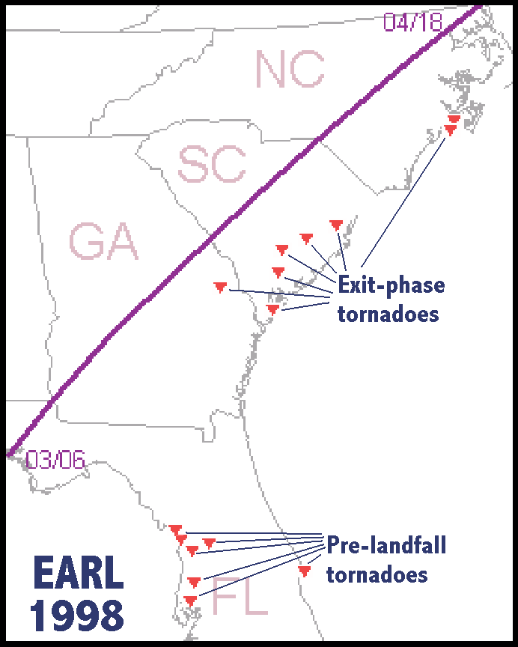

Figure 1: Example of a single-column figure. If hyperlinked to a larger version, insert the following text at the end of the caption: Click image to enlarge. If hyperlinked to multimedia, insert text (e.g.: Click image to play video.)

c. Radar signatures

Previous research has identified radar signatures that may give insight into the location of damaging surface winds with some bow echoes. The most notable radar signatures are bookend vortices (Fujita 1978; Weisman 1993) and rear-inflow jets (Smull and Houze 1985, 1987; Houze et al. 1989). Miller and Johns (2000) also showed cases in which extreme wind damage was associated with supercells embedded within derechos. This study sought to determine the frequency of bookend vortices, rear-inflow jets, and supercells in cold-season bow echoes.

In a mature bow echo, cyclonic and anticyclonic bookend vortices develop north and south, respectively, of the channel of rear-to-front flow (Weisman 1993). For simplicity, only the northern bookend vortices were examined in this study. A northern bookend vortex was defined as a cyclonic mesoscale vortex located north of the bow-echo apex. The vortex must have persisted for at least 1:45 to be considered a distinct component of the bow echo rather than a transient vortex. General rear-to-front storm-

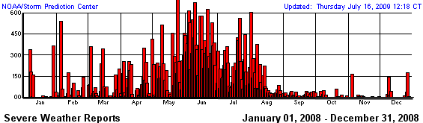

Figure 2: Chronological bar graph of daily severe weather report counts over the conterminous United States from 2008. Convective days represent the period 1200 UTC to 1159 UTC the next day. Illustrates placing a figure or table across two columns. [Provided by Storm Prediction Center.]

relative flow is present in a majority of squall lines (Houze et al. 1989). The rear-inflow jet as defined for this study, however, was a horizontally compact maximum of storm-relative inflow in the middle levels of the convective system near and just behind the leading edge. The Glossary of Meteorology (Glickman 2000) defined a supercell as "…a single, quasi-steady rotating updraft, which persists for a period of time much longer than it takes an air parcel to rise from the base of the updraft to its summit (often much longer than 10-20 minutes)". Based on this definition, a cell was considered a supercell if the Doppler radar velocity signature of a deep, rotating updraft could be followed for one hour or more. All of the supercells observed during this study persisted for well over one hour.

d. Environmental parameters

Some of the difficulties in choosing appropriate proximity soundings for deep moist convection have been discussed previously (e.g. Brooks et al. 1994). In this study, proximity soundings were required to have been taken within 300 minutes (5 hours) and 300 km of the path of the bow-echo apex as it appeared in WSR-88D data. Furthermore, the soundings must have been uncontaminated by convection, and located ahead of the path of the bow echo. Surface and upper-air maps were inspected manually to ensure that each sounding was representative of the environment immediately ahead of the bow echo. In some cases, to better represent the environment from which a bow echo formed, the surface observation in the sounding was substituted with a surface observation taken immediately ahead of the convection at the time of bow-echo start.
Shear was defined as the vector difference between winds at the top of a layer and the bottom of a layer. The 0–2.5-km, 0–5-km, and 5–10-km AGL shear vectors were computed to investigate low-level, mid-level, and upper-level shear, respectively. Using WSR-88D level-II data, bow echoes were tracked at their apexes to estimate system direction and speed. System-relative winds (hereafter, SRW) could then be estimated. CAPE and the mean mixing ratio in the lowest 100 hPa AGL were computed to measure instability and low-level moisture, respectively. Lifting condensation level (LCL), level of free convection (LFC), and CAPE were calculated using the most unstable parcel in each proximity sounding.

Table 1: EJSSM table example. Tables should have at least outer bordering. Color-shading is optional. Table captions are placed above tables, while figure captions go below figures.

TROPICAL CYCLONE | YEAR | TORNADO  REPORTS
H Ivan* | 2004 | 118
H Beulah | 1967 | 115
H Frances | 2004 | 103
H Rita | 2005 | 98
H Katrina | 2005 | 59
H Andrew | 1992 | 56
TS Fay | 2008 | 50
H Gustav | 2008 | 49
H Cindy | 2005 | 48
H Georges | 1998 | 48
* Notations appear immediately below a table.

Acknowledgments

The authors would like to thank Joshua Palmer of North Carolina State University (formerly of NSSL) and the staff at NCDC whose help in providing Level-II WSR-88D data was much appreciated. Don Burgess of NSSL and Dr. Howard Bluestein and Dr. Michael Richman of the University of Oklahoma lent helpful ideas and reviews when this work was first presented as a Master’s thesis. Robert Johns of the Storm Prediction Center also helped steer the research toward operationally important issues. Composite maps were provided by NOAA-CIRES Climate Diagnostics Center, Boulder Colorado from their web site (http://www.cdc.noaa.gov/). Funding was provided by NOAA/OAR/NSSL under NOAA-OU Cooperative Agreement #NA17RJ1227.

APPENDIX

Appendices appear in this part of a paper when offering accessory analyses, tables, lists, supplemental figures, or datasets that are not primary to the theme of the main manuscript. Other examples of information suited for appendices include complex derivations, lengthy examples and survey questions. Always refer to each appendix from the main text, in chronological order. If using more than one appendix, label them as “APPENDIX A”, “APPENDIX B” and so forth. Tables, figures and links must be embedded in the body of the appendix, and can cover one column or full-page width as necessary for legible display.

REFERENCES

Adler, R. F., and Coauthors, 2003: The Version 2 Global Precipitation Climatology Project (GPCP) monthly precipitation analysis (1979–present). J. Hydromet., 4, 1147–1167.
Brooks, H. E., and D. J. Stensrud, 2000: Climatology of heavy rain events in the United States from hourly precipitation observations. Mon. Wea. Rev., 128, 1194–1201.
——, A. R. Anderson, K. Riemann, I. Ebbers, and H. Flachs, 2005: Climatological aspects of convective parameters from the NCAR/NCEP reanalysis. Atmos. Res., submitted.
Cortinas, J. V. Jr., B. C. Bernstein, C. C. Robbins, and J. W. Strapp, 2004: An analysis of freezing rain, freezing drizzle, and ice pellets across the United States and Canada: 1976–90. Wea. Forecasting, 19, 377–390.
Dai, A., 2004a: Global precipitation and thunderstorm frequencies. Part I: Seasonal and interannual variations. J. Climate, 14, 1092–1111.
——, 2004b: Global precipitation and thunderstorm frequencies. Part II: Diurnal variations. J. Climate, 14, 1112–1128.
——, and K. E. Trenberth, 2004: The diurnal cycle and its depiction in the Community Climate System Model. J. Climate, 17, 930–951.
Dodd, A. V., 1965: Dew point distribution in the contiguous United States. Mon. Wea. Rev., 93, 113–122.
Doswell, C. A. III, and L. F. Bosart, 2001: Extratropical synoptic-scale processes and severe convection. Severe Convective Storms, Meteor. Monogr., No. 50, Amer. Meteor. Soc., 27–69.
Fujita T. T., 1993: Plainfield tornado of August 28, 1990. The Tornado: Its Structure, Dynamics, Prediction and Hazards. Geophys. Monogr., Vol. 79, Amer. Geophys. Union, 1–17.
LaDue, J. G., and E. A. Mahoney, 2006: Implementing the new enhanced Fujita scale within the NWS. Preprints, 23rd Conf. on Severe Local Storms, St. Louis, MO, Amer. Meteor. Soc., 5.5.
Minor, J. E., J. R. McDonald, and K. C. Mehta, 1977: The tornado: An engineering-oriented perspective. NOAA Tech. Memo. ERL NSSL-82, 196 pp. [NTIS PB-281860/AS.]
NOAA, 2007: Storm Data preparation. National Weather Service Instruction 10-1605, 9 pp. [Available online at http://www.weather.gov/directives/sym/pd01016005curr.pdf]
Ostuno, E. J., 2008: A case study in forensic meteorology: Investigating the 3 April 1956 tornadoes in southwest Lower Michigan. Electronic J. Severe Storms Meteor., 3 (1), 1–33.
Schultz, D. M., 2009: Eloquent Science: A Practical Guide to Becoming a Better Writer, Speaker, and Atmospheric Scientist. Amer. Meteor. Soc., 412 pp.
Tufte, E. R., 1983: The Visual Display of Quantitative Information. Vol. 914, Graphics Press, 197 pp.

REVIEWER COMMENTS

[Authors’ responses in blue italics.]

REVIEWER A (J. Q. Scientist):

Initial Review:

Recommendation: Accept with minor revisions

General Comments: Overall, this was a lively and thorough treatment of the subject, with well-stated hypotheses, methodology and conclusion. Data appeared to be analyzed optimally for the approach proposed, although I do have one concern with the lack of additional data within, and analysis of, the extremes of the distribution, as discussed in specific comments. The work also can benefit from incorporating more background material, including some references that I will suggest regarding both the statistical methods employed and the role of orographic forcing in the development of the convection n these settings.

Substantive Comments:

Please provide more insight into the rationale behind the lack of distributional limbs in the dataset, and add more prior events over the same geographic domain. Illustration of the resulting distribution, using something fairly straightforward to interpret (i.e., a box-and-whiskers diagram) would provide a clearer picture of the relative commonness of fringe events in the data.

This is a valid point. Given the exploratory nature of this research, however, we choose to proceed with the dataset currently collected. We have, however, provided just such a diagram as applied to the existing data (the new Fig. 8), which indeed does reveal the far-flung nature of the extreme points from the middle quartiles of the distribution. Thank you for the suggestion.

[Minor comments omitted.]

This is an example of a footnote.

